***Product Specifications***

**Model number：LHCT004**

**Products name: 2.4G 3 Zone Touch Remote RGB Controller**

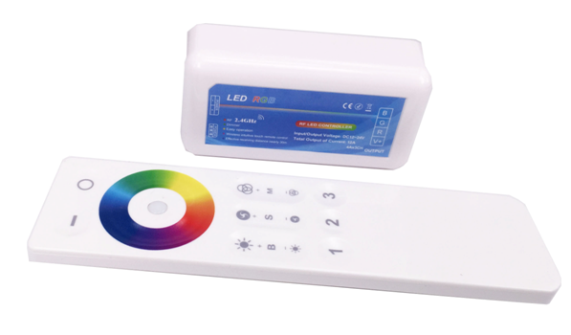

**Product Description**

This 2.4G 3 zone Touch Remote RGB controller is human touch type and key control type universal RGB controller. Adopting the most advance PWM control technology, can control all kinds of 3 channel (common anode) and 4 wires LED lights. Such as LED module, led strip, led control box, led source, etc. This controller is easy to connected with wires and very simple to use. It is with synchronous indicating light and power off memory function. User can choose different changing mode, adjust the speed and brightness, turn on/off by the remote controlling. User can get flash effect, strobe effect, fade effect etc according to their demand .

**Technical Parameters**

● Working temperature：-20~55℃

● Supply voltage：DC12V~24V

● Output：3 Channel

● Connection mode：Common anode

● Controller size：L85×W45×H23mm

● Remote size：L150×W40×H13mm

● Static power consumption：<1W

● Output current：<4A/CH

● Output power：12V:<144W；24V:<288W

**External dimension**

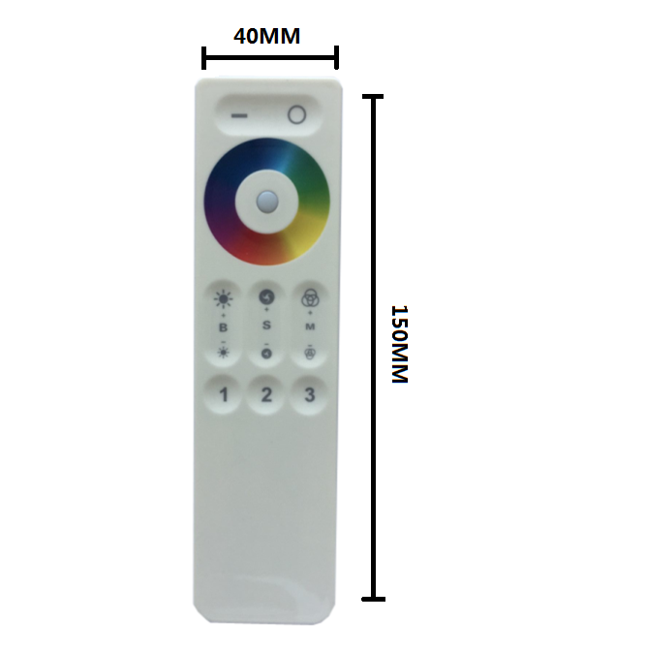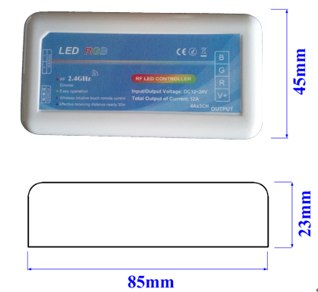

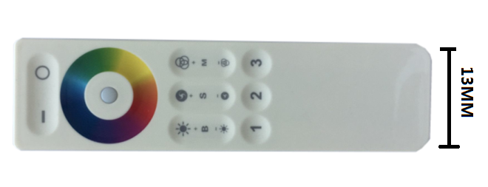

**Connection description**

**Power input interface:**

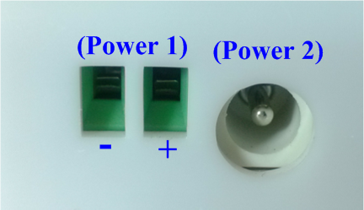

Power 1: Adopt wire plug-in and screwing terminal power input

Power 2:Adopt the DC female Connector.

**Load output interface:**

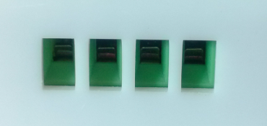

Adopt wire plug-in and screwing terminal output

**Direction for use:**

● **Remote Function introduction：**

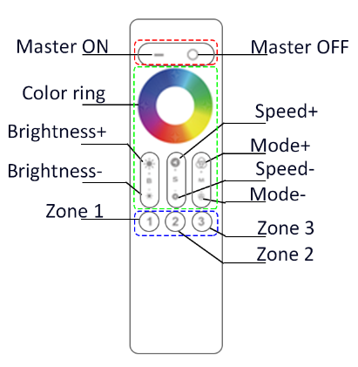

|  |  |  |
| --- | --- | --- |
| **Item** | **Parameter** | **Remark** |
| Supply Voltage | 3V | 2*AAA batteries |
| Transmission Frequency | 2400-2483.5MHz |  |
| Control Mode | GFSK |  |
| Transmission Power | 6db |  |
| Static power consumption | 10uA |  |
| Remote distance | 20-30m |  |
| External dimension | 150×38×13mm |  |

**● Remote Function introduction：**

1、Use the 2.4G frequency RF remote control, no need to make the remote direct to the controller, and the RF remote can control it across obstacles.

2、In the open area remote control distance is about 30 meters.

3、Adopt touch control remote, slightly touch the color wheel can switch the light color easily and smoothly

● **Operation method:**

1、Connect the load wire at first, following by the power wire; Please make sure no short circuit between connecting wire before you turn on the power;

2、Only the ON button is effective in the OFF station, press the power button for the first time then controller will enter to the last mode before turn off the controller last time (memory off function).

3、**Match code and clean code Instruction：**

For a new combination, the remote have to match code with the receiver then it can be used normally. Before match code, switch on the power to check if the LED Controller, power supply and led light are connected correctly.

**Match code:** Switch off the power, then Switch on again (within 5 seconds)long press the “Group X(X=1,2,3)”Button for 2 seconds. the output led light will be quickly flash for 3 times, this means the remote is matched code with this receiver successfully, they can be used normally.

For example: there are A and B controller. Firstly, Switch on the power for A(within 5 seconds)long press “Group 1”button for 2 seconds, the output led light will be quickly flash. “Group 1” can control A controller.

Secondly, Switch on power for B(within 5 seconds)long press “Group2”button for 2 seconds, the output led light will be quickly flash, “Group 2” can control B controller

When long press Master OFF button, Both A and B will be turned off, then short press Master ON button, Both A and B will be turned on, A and B can be controlled in the same time. Well, if A is turned on and B is turned off , short press Master ON button, the A will be turned off, B will be turned ON

If need control A independently, press GROUP 1 firstly, then the touch ring can control A only. Similarly, for Group 2 and Group 3.

**Remark**: a remote control can operate 3 groups of controllers at the same time. each group of controllers can be composed of many controllers, such as 30 controller divided the 3 groups, then, each group control can remote 10 controllers, to achieve synchronously adjustable brightness effect.

**Clean code:**

If need change the Group combination, the link between remote and receiver can be cleaned. Then rebuild the link as required.

Code clean method：

Switch on power for controller(within 5 seconds)long press “GROUP X(X=1,2,3)”button for 2 seconds, the related led light will be quickly flash for 9 times, that means this group has been cleaned code.

**Remark**: our factory default for set package is Group 1 linked to controller. User can build link according actual demand. One remote can be linked with countless controller, one controller only can be linked with 2 remotes.

4、Press ON button to start, then press mode button can switch the 9 modes as following：

|  |  |  |
| --- | --- | --- |
| Number | Mode | Adjustable state |
| 1 | 3 colors jumping change | Brightness is adjustable, speed is adjustable |
| 2 | 3 Colors fade in and fade out |
| 3 | Seven colors jumping change |
| 4 | Seven color fade |
| 5 | White color fade in and fade out |
| 6 | Red color fade in and fade out+ flash 3 times |
| 7 | Green color fade in and fade out+ flash 3 times |
| 8 | Blue color fade in and fade out+ flash 3 times |
| 9 | Auto-cycle mode |

**Typical Application**

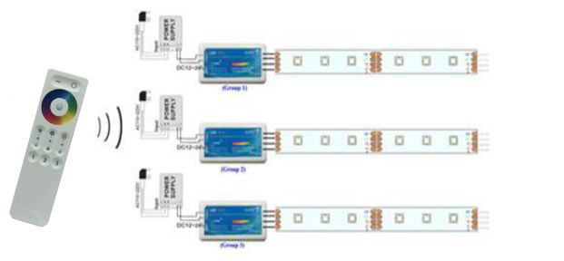

**CAUTIONS**

1, This products Input voltage is DC12-24V,other input voltage are not allowed.

2, Lead wire should be connected correctly, according to the wire color and the connecting diagram offers；

3, Overload are prohibited.

4, In order to promote the touch sensitive of the color wheel, please don’t touching the touch color wheel when installing the battery to the remote, if sensitive are low, please remove the battery and re-install it again.

5, Please do not used the controller around a wide range of mental area or do not used nearby strong electromagnetic wave area, otherwise,  it will seriously affect the remote distance.