Product Specifications
Model number：LHAMP001
Products name：Aluminum Shell RGB Amplifier
Product Description:
This Aluminum shell RGB amplifier is suitable for all kinds of constant voltage led RGB controller. It can enlarge the led controller signal through the RGB to receive the PWM(pulse width modulation),and output the signal to the load ,then it can make the same effect with the controller.when add each additional amplifier, can connect and controlled twice more LED lights.theoretically , one controller can connector with thousands of this RGB amplifier, and can make the same effect.

Technical Parameters:
● Working temperature：-20-60℃
● Input voltage：DC12~24V
● Output：3 circuit
● Connection mode：Common anode
● product’s size：L105×W65×H23mm
● package size：L115×W70×H35mm
● Net weight：110g
● Gross weight：125g
● Static power consumption：<1W
● Output current：<4A/CH (8A/ch For optional)
● Output power： 12V/4A < 144W；12V/8A< 288W；24V/4A< 288W；24V/8A< 576W.
External dimension:

（Package size）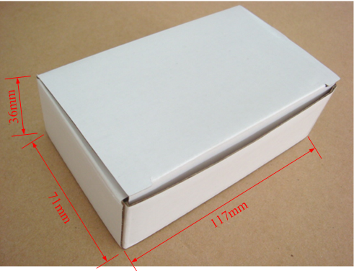

Connection description:

Power input interface:(port 1)：
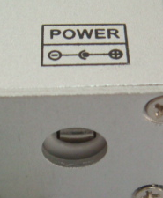 Adopt the 5.5x2.1mmDC plug connector seat

Power input interface:(port 2)
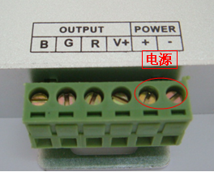 Used the plug seat with screw
Signal input interface:
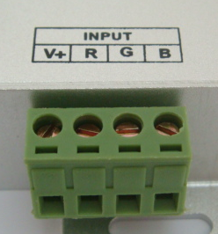 Used the plug with screw
Load output interface:
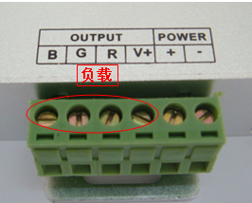 Used the plug with screw

Direction for use:
Connect the input and output wire in sequence according to the specification one the label of the amplifier, make sure that no short circuit phenomenon,then connect the amplifier to the DC12V/24V power supply , and used with the led light , the wiring diagram are as follows:
Typical Applications:
application circuit 1——serial connection，used one power supply：

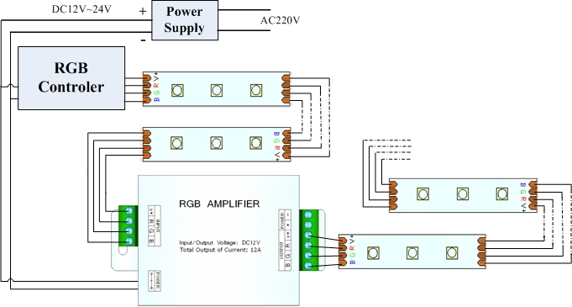

application circuit 2——serial connection，used two or more power supply：

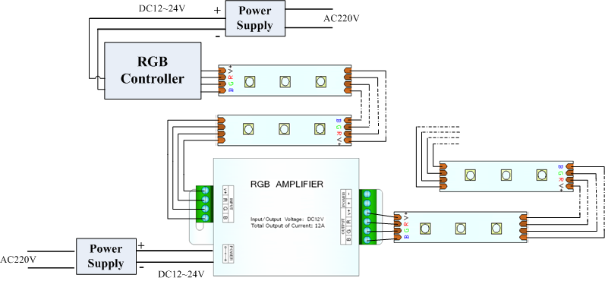
application circuit 3——parallel connection，used one power supply：

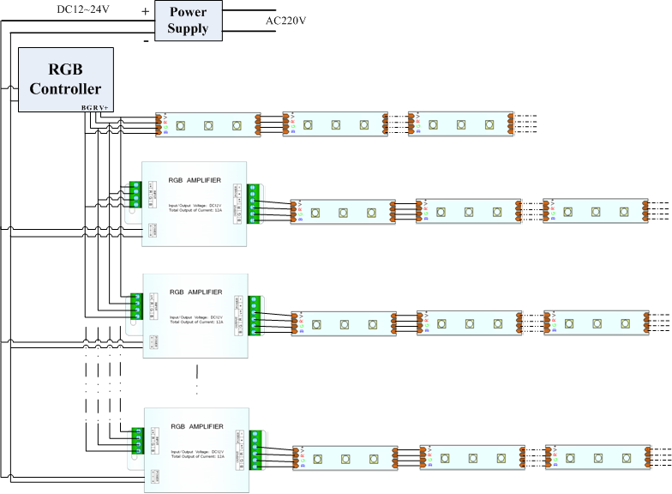
application circuit 4——parallel connection，used two or more power supply:
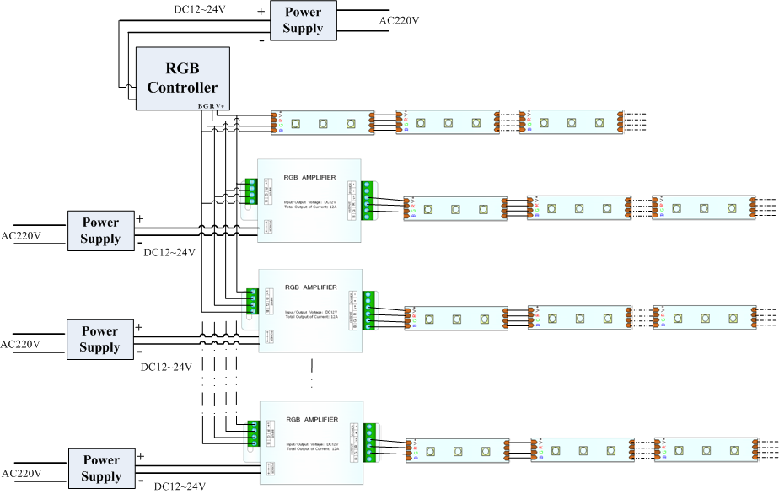


Cautions:
- This products Input voltage is DC12-24V,other input voltage are not allowed.
- Lead wire should be connected correctly,according to the wire color and the connecting diagram offers.
- Overload are prohibited.

